With this php files it is possible to have your eq-3 valves controlled by Domoticz.

I use it to control the eq3 max valves/thermostats. Only the php scripts and a little (easy) blockly scripting in Domoticz is needed. Below you find the setup instructions.

I took this approach because I could not get de Max Buddy implementation to run (stable) in my environment. Furthermore I am not familiar with Python and Bash, so I decided to go forward with php.

The scripts (eq3………php) can also be used without Domoticz in case you want to write you own application. The scripts reads values from your cube, and you will be able to set temperature of the cube. The scripts lacks functionality like holiday modus, etc. I use Domoticz for this kind of logic (and various other scenario’s).

As I only own a Eq3 Max cube and some valves, I developed code for this setup. In case you want to control other Eq3 Max devices, for example a wall thermostat you will need to do some additional coding.

The eq3class.php is based on code created by Mega (<http://www.mega-nas.de/max/>). I Just took his code and isolated the logic from the html. Did some rewriting to get a better understanding. Also solved some issues I ran into.

It runs very stable in my environment (rPi 3) and PHP also running on the Pi. While developing, I ran the php scripts on a Windows environment, also without any troubles.

I hope this helps to get the maximum comfort out of your Eq3 Max. I needed it to automate temperature in my house. Furthermore with the Domoticz mobile app, you can also control the Eq3 Max valves from remote location. Although an Eq3 Max mobile app is in the app shop, often temperature set in mobile app is not executed and the app lacks several options.

All script files contain a example of how to call the script, assuming you are running php on a localhost and have the script files in folder “eq3”.

I run these scripts (and Domoticz) on rPi (version 3).

Before you start this setup instructions you will need to do the basic hardware installation of the valves and the inclusion (teach-in) of the valves in your cube. You will need to do this as described in the installation manual included with your hardware. I assume you already executed this, so you don’t need to do it again.

SETUP:

1. Put this folder on a webserver that runs php. If you interested in using these php-srcipts, I assume you know how to run php. I will not explain how. I run a php webserver on rPi.
2. Change script file appsettings.php. In this script you need to change the ip-address of your eq-3 maxcube and the ip-address of Domoticz. I case you are not using Domoticz put a dummy value in the Domoticz ip-address, or comment this code line.
3. You now should be able to run eq3read.php. This will give a very basic output of your eq-3 cube values. If this script does not run, first figure out how to get this script running. If this does not run, probably nothing else will.
4. So far so good? Now you can run “domocreatenewhardw.php”. This will create your devices in Domoticz. Now you should be able to see in Domoticz on your utility tab for each valve, something like this:

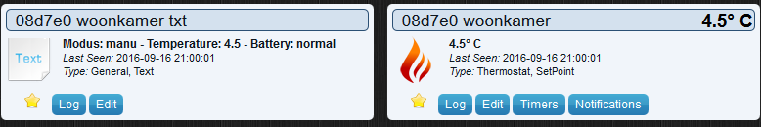

1. So far so good? Now you need to do some Blockly scripting. For each valve create the following script. It will execute if you change the temperature with the domoticz software device. I have 4 valves, so I created 4 scripts.

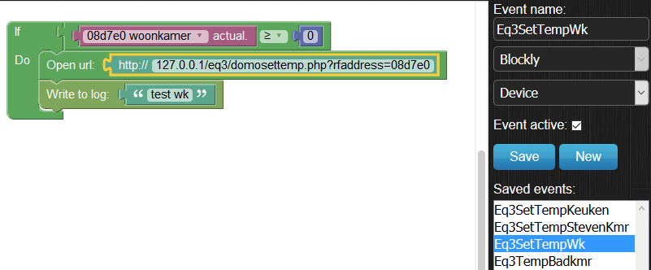

* + The first line of the script (the “if” statement) choose the valve/thermostat device. This is more or less a dummy statement that triggers the execution because it mentions the devicename.
  + The second line (the open url statement) should be the url to the domosettemp.php script. After “?rfaddress=” put the first 6 characters of your valve/thermostat name. (The first 6 characters of your valve/thermostat name is de rf address of the valve.)

The domosettemp.php reads the temperature you just set with domoticz (see screenshot below) and sets to temperature of the valve to this value.

* + The last line (the “write to log” statement) is not necessary. I use it for test purposes. It writes a line in domotics log, so I can see if its executed.

Now step 5 is finished, you can change temperature of your valves/thermostats in Domoticz

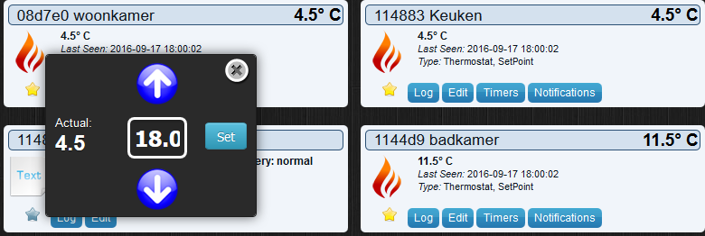

1. Now create a script to execute domoupdatesensor.php every minute. It updates the value of the eq3 devices, if the temperature is changed not using Domoticz (for example you manually changed temperature, or by the eq3 max mobile app).

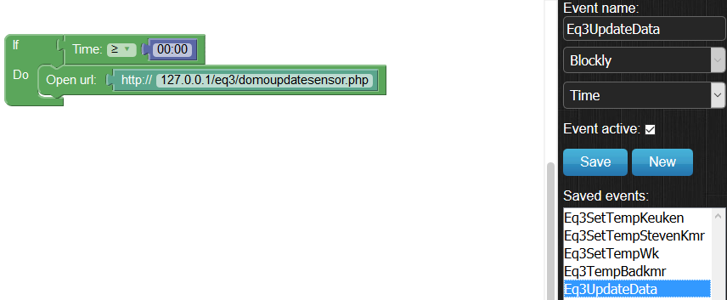

1. Now use your imagination to automate things further. For example a simple script the set the temperature of the valves in my living room and my kitchen at 21 degree, at 16:00 on weekdays.

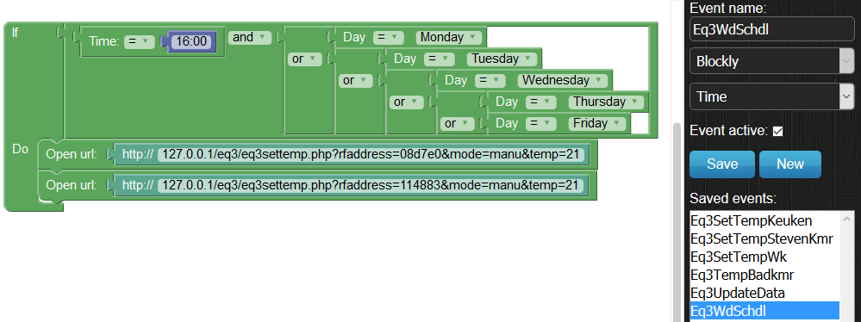

Known issues:

1. When you run the eq3 max! software the cube information is locked for any other application, like my php scripts. When you run eq3read.php the following message is displayed “110Connection Error - Connection timed out”. So if you need to use the factory software, close it as soon as you finish.
2. Once one of the valves did not respond to any of the scrips above, neither did it respond to the factory software. I rebooted the cube (1 minute power off and then power on again) and this issues was solved. I think my scripts are not involved in this issue. This happened to me once in two years.
3. I once experienced all the valves were gone from the cube. You need to teach-in the valves again. This issues is not related to my scripts. I read people running into the same issue, with only factory software. This happened to me once in two years.